P1 and P2 Home Learning: A Guide for Parents

Dear Parent /Carer

As you will be aware, the Scottish Government have made the decision to close schools from Monday 23 March.

We are very keen to ensure that every child continues to learn and thrive while schools are closed. We have been working very hard over the last few days to make plans which ensure that` ensure their learning does not suffer. However, we understand than many parents are not trained teachers, and need to work from home while supervising their child’s learning.

We understand how important clear communication is during these challenging times. The school website will be our main mean of communication, although we will continue to use Groupcall.

We are going through a period of uncertainty and change which can be very stressful and worrying. Our One-ery and Two-ery teams wish to support you and your learner in ways that provide assistance to you during this period, without us leaving you feel overwhelmed.

This is also an opportunity to ‘just be’ with your learners. Some will be feeling anxious, excited or nothing at all. This is normal and expected under these circumstances. So, if you can, now is a time to play outside and go on walks; bake cookies and paint pictures; play board games and watch movies; do a science experiment together or find virtual field trips of the zoo; start a book and read together as a family; snuggle under warm blankets and do nothing.

However, some will miss their daily contact with their teacher and their friends. You may be working from home and need some help to keep them occupied. Or you may need a bit of structure to help you through the long days. Here is how we can help.

Learning Journals Online
Your learners e-learning journal will be our main form of communication with you in the event of a school closure. It allows us to send messages directly and instantly to you; and will allow us to upload videos and learning aids to support your child’s learning.

We hope you will also take advantage of the parent contribution area on Learning Journals. This allows you to create your own mini-observation from home and send messages to the teachers. Remember there is a parent app for both iOS and android, which allows you to access your account from your phone. We feel it is very important to try to keep our One-ery and Two-ery communities at this time, so our home teachers will be sharing updates with their home teams to allow our learners to still see their friends.

We have tried our best to meet the needs of you and your learners. Please don’t hesitate to get in touch if you have any questions either through the online journals or parent reps. We have tried to make the learning we provide, manageable, fun and reflect the learning that happens in the One-ery and Two-ery.

If you have any concerns about accessing your learner’s Learning Journal, please contact the school office asap and we will support you with this.

What will learning look like?
Each day you will get an update by 10am on your Learning Journal:
- Monday: Literacy
- Tuesday: Numeracy
- Wednesday: Literacy
- Thursday: Numeracy
- Friday: Writing

Literacy and Numeracy will be planned by your learners’ Teacher Time Teacher and will suit their needs and ability. The learning will consist of an input, then some practical activities for you learners. We have recently undertaken some assessments so learning will be differentiated to individual needs.

As well as our specific learning, there are lots of things that will help your learners retain pace and challenge within their learning and will all aid to their progress. We have put together a document that we hope you find helpful. These are things that you can do daily, and dip in and out of.

In P2, we have provided learners with a jotter (something they are familiar with) which they can use to undertake their activities. In P1, our learners can use a whiteboard (if you have one) or blank paper and a pencil.

What else can we do?
In P1, our next River Time focus is ‘Help Our Planet’. This is designed around what we can do to help the planet we live in, e.g. Plastic, Kindness, Palm oil, Pollution, Recycling, Animals. In P2, their next River Time focus is ‘Budding Engineers’. This is an opportunity to look at famous engineers and designers; and consider how things are constructed.

If learners would like to carry out some research based on these different concepts then they can be linked to our curriculum and a focus for learning. There is no pressure to produce anything but it can allow your learner to follow an interest they have.

What will my day look like?
A typical structure to your day, may look like this:

Time |  | Activity
9am-10am | 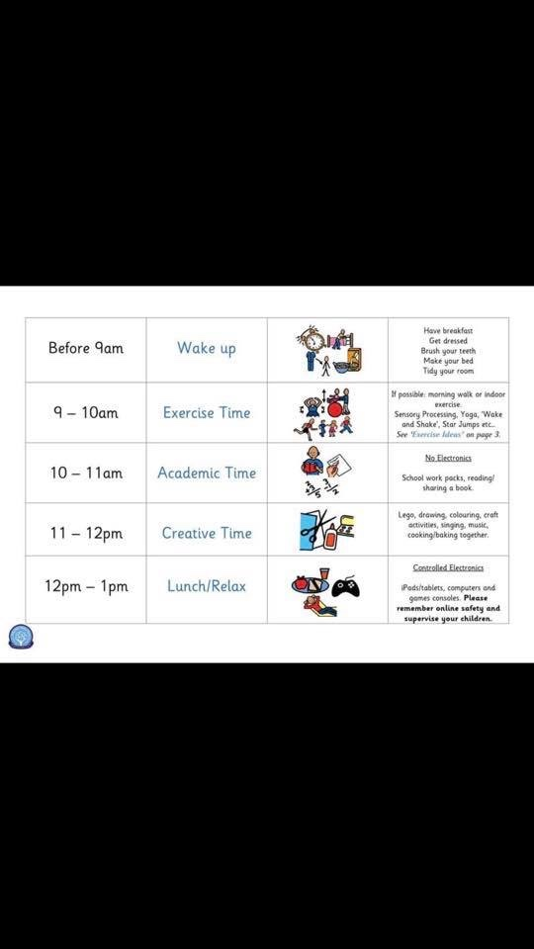 | Movement Time (go for a walk, play in the garden, mini yoga)
10am–11am |  | Teacher Time (check online learning journals for details of learning for literacy or numeracy)
11-12 noon | 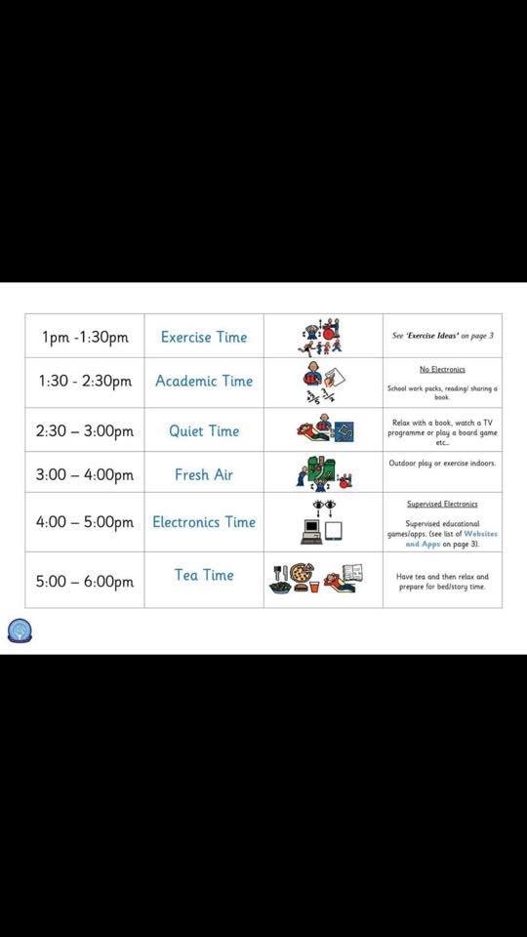 | Quiet Time (read books, draw, jigsaws etc.)
12noon–1pm |  | Lunch Time (help to prepare lunch, set the table, wash the dishes)
1pm-2pm |  | Creative Time (paint, playdough, Lego, craft, River time research etc).
2pm-3pm |  | Afternoon Fresh Air Time (go for a walk, play in the garden, walk the dog etc.)

Please don’t worry about what they are missing at school or that they may regress. When we are all back together again, our fabulous teachers will continue their learning to meet their needs and plan next steps for learning appropriately. We will be able to revisit skills and concepts that your learners may have missed and will ensure that any misunderstandings are rectified.

We would like to use the Sway newsletter as a place for parents to share ideas and resources that they have found useful- perhaps a card game that your family enjoy, or a walk that suits young legs, or an art project that has been fun.
We would like this to be a way that the school community can come together and help each other in these challenging times.
Please send photos and a brief explanation to susan.morgan@southmorningside.edin.sch.uk.

