Dear New S1s,
We are delighted to welcome you “Virtually” to Boroughmuir. Here is your timetable for your 3 Day Visit. We have tried to keep this as close to the real experience for you. We have been busy creating some learning to give you a flavour of S1.
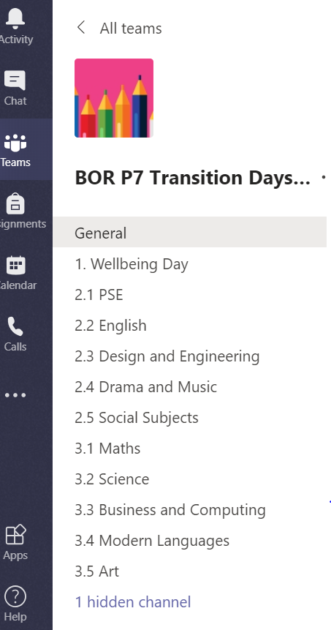
You can do the whole day as if it was an actual Boroughmuir High school day and we have included the period times. This may be a little different in August but it will give you a good experience of changing lessons and subjects.
If this doesn’t work for you or your family, just do what you can when you can. The lessons will stay on here for you – your P7 Teachers are around too.
There is also a channel with all our Welcome Videos for you to watch or re-watch.
This includes the Virtual Tour (27 minutes)! This should keep you busy too. I have added the Teams channel on to your timetable for each lesson. Remember the lessons will all stay on the Team to give you time to go back or work around your family!
Please use the “Ask BHS Teachers” channel to ask us some questions – we will be around on these days to help you.
Equipment you may need…
- Something to write with and some paper
- To join in the Science Experiments 4 to choose from so don’t worry if you can’t get all this:
- Food colouring - 6 colours if possible, Cooking oil, Salt, String, A fizzy tablet - vitamin c, alka seltzer type thing, Sugar, a straw.
- Phone if you have one to take photos for Art

My Virtual 3 Day Visit Timetable 2020
Tuesday 16th June | Wednesday 17th June | Thursday 18th June
Wellbeing Day  (Meggetland Replacement) | Day 1 of Timetable  8.45-9am Assembly Ms Presly & Mr Dempster  Option to re-do virtual tour of school if you have time… | Day 2 of Timetable  Earlier start – finish tour if you need to…
Channel 1. Wellbeing Day
9-11am
Mr Collard (Sports Leaders)
& Active Schools -Tony Segall
Break – 11-11.30

11.30-1pm
Ms Mitchelmore

Lunch 1-2pm

2-3.30
Mr Igoe and Mrs O’Thy

 | Channel 2.1 9-9.40  PSE - Personal and Social Education | Channel 3.1 8.45-9.40  Maths – Mrs Macpherson
 | Channel 2.2 9.40-10.35  English – Ms Stratton | Channel 3.2 9.40-10.35  Science – Ms Hearnden
 | Break – you have earned a snack and a drink of water! | Break – you have earned a snack and a drink of water!
 | Channel 2.3 10.50-11.50  Design and Engineering - Mr McDonald | Channel 3.3 – 10.50-11.50 Computing & Business  Mrs Braisby and Miss Boag
 | Channel 2.4 11.50-12.50  Drama and Music – Mr Graham | Channel 3.4 11.50-12.50  Modern Languages – Mr Alexander
 | Lunch – have some food and fresh air if you can! | Lunch – have some food and fresh air if you can!
 | Channel 2.5 1.35-2.30pm Social Subjects Task – Virtually or physically (if safe to do so and social distancing).  Miss Mackintosh and Mr Das | Channel 3.5 1.35-2.30pm  Art – Mr Thomson

