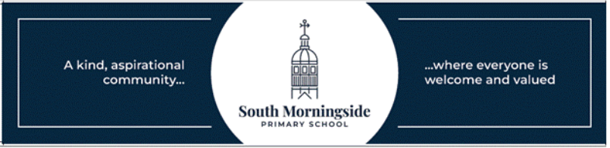

South Morningside Feedback Policy

Feedback is a very important part of learning, and we strive to offer this in the most effective way. We know that, in most cases, verbal and instant feedback is the most effective way to move learning forwards. There will not be a lot of written feedback in jotters and workbooks as, in most cases, children benefit more from being involved in the feedback process, through discussion or self- and peer- assessment at the time of doing the work, rather than reflecting afterwards.
At South Morningside, we use a variety of methods to mark and give feedback to learners. This includes:
- Verbal Feedback
Teachers will discuss the work with the children to give next steps and feedback about the work undertaken. This is a very effective way of ensuring engagement by giving feedback during or immediately after the work has been done. This is the most common way feedback is given.
- Self Assessment
With support from staff, pupils can self-assess their work against targets they have been given beforehand and establish next steps. They might do this in writing, verbally or by highlighting aspects of their work. This is an important way for pupils to reflect on their own work and improve it.
- Peer Assessment
Where appropriate, children can peer-assess each other’s work against targets and establish next steps. They might do this in writing, verbally or by highlighting aspects of a partner’s work. Staff will support the children in doing this to ensure they are comfortable with the process, and that the peers are appropriately matched. Children are engaged and learn from assessing each other’s work.
- “Tickled Pink” and “Green for Growth”
Using pink and green pens or markers, children and/or staff can highlight the aspects of their work that they feel are very good in pink and areas to work on or improve in green. Depending on the task and stage, they may go into more detail verbally or in writing.
- Show Me Boards
Children use their whiteboards to write or draw their answers, thoughts and ideas, then they are encouraged to show these to the teacher, who can quickly gauge what level the learners are at and the next steps for the learning.
- Written feedback
Staff may write feedback on jotters, workbooks or worksheets for children to read. This is limited to more formal assessments and in instances where the other methods of feedback are not appropriate. There may be stamps on some physical work to show evidence of feedback, but this does not feature on all work as feedback may have offered undertaken in other ways.
- Whole Class Feedback (WCF)
The teacher reads through all the students' work, makes a note of the things they did brilliantly and the areas where they could do with a bit of improvement and then shares this feedback with the entire class as a whole but without giving specific names.
As a whole school, we Quality Assure all learning and teaching to ensure consistency across stages and year groups. Feedback must be effective and have an impact.
To find out more :
https://theteachingdelusion.com/2021/12/11/feedback-focus-on-useful-which-means-focus-on-how/

