South Morningside Primary School
Play Policy


“Playful Pedagogy is a way of integrating children’s play experiences with curricular learning, giving pupils the flexibility to find their own solutions to both new and existing problems. It engages children in personally meaningful activities, learning about themselves and others, and encourages autonomy and their independent motivation-to-learn”. ​
(Play Scotland)
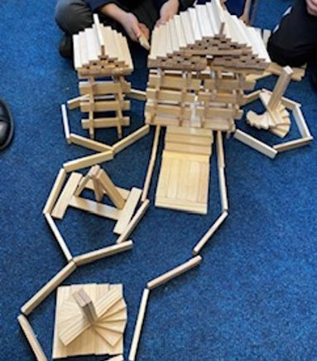
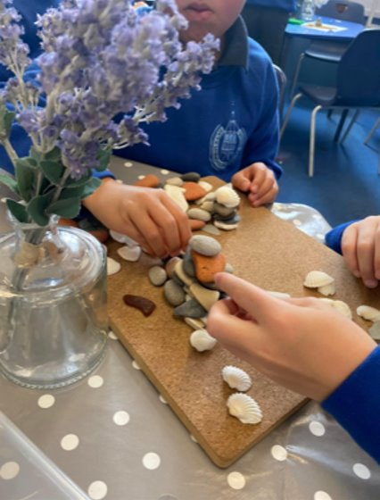
What is play?
UNCRC (United Nations Convention on the Rights of the Child) article 31 states that all children have the right to play.
“Play is a process that is freely chosen, personally directed and intrinsically motivated. That is, children and young people determine and control the content and intent of their play, by following their own instincts, ideas and interests, in their own way, for their own reasons.”
Playwork Principles

Building the Curriculum highlights the importance of active learning in the early years in terms of:​
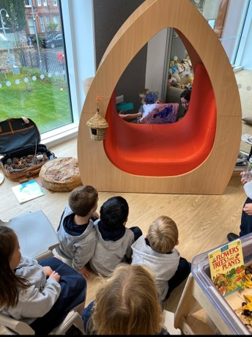
​
- Spontaneous play ​
- Planned and purposeful play ​
- Investigating and exploring ​
- Events and life experiences​
- Focused learning and teaching

The benefits of play
Through play, a child develops their cognitive, social, emotional, and physical capacities. We know how important it is for children to be given time to play throughout the day to follow their own line of enquiry or individual interest. (Education Scotland- Play pedagogy toolkit).

Psychologists have suggested that spontaneous play is natural and healthy for children and children learn best through play. Through play all areas of child development can be enhanced: social, emotional, physical, cognitive, language and literacy skills and self-regulation (Ginsburg, 2007).

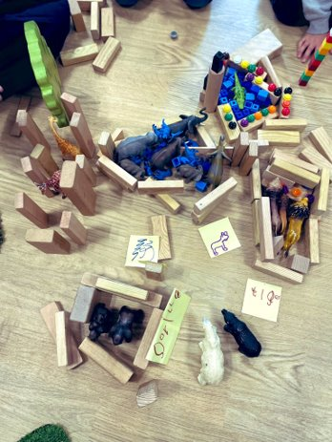
‘Research has shown that high quality early years provision promotes children’s development and learning and, in the longer term, enhances their education and life chances’ (Sylva 2014 cited in Realising the Ambition 2020).

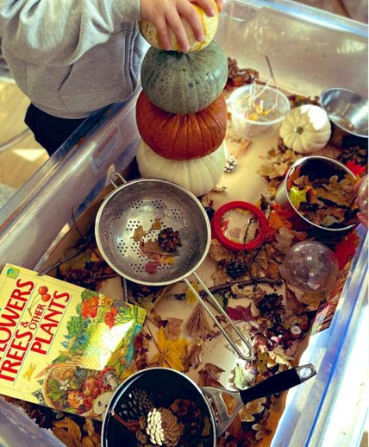
At South Morningside, we strive to provide a motivating and nurturing learning environment to allow learners to reach their full potential through play-based pedagogy. Our values and principles are based on robust research and evidence around how children learn most effectively and we aim to provide learners with high quality learning and teaching opportunities. Our setting allows a smooth transition from nursery and allows children freedom and choice, building on their previous skills and experiences acquired at nursery.
We have embedded Curriculum for Excellence (CfE) in a creative, self-motivating, and purposeful way to allow children to lead their own learning and make progress through Early Level and acquire skills for life. In P1, we plan an engaging and responsive Continuous Provision across the learning spaces. Learners have the freedom to move freely across the Continuous Provision allowing them to build on a number of skills including creativity, problem solving, negotiation, turn taking, decision making, independence, curiosity and mastery.
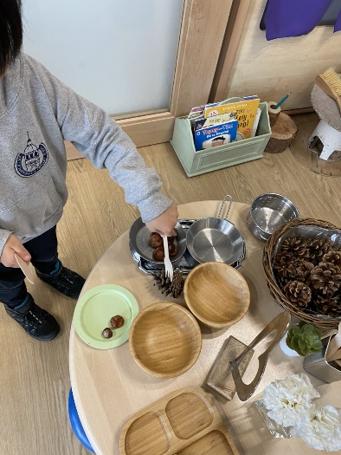
As teachers and practitioners, we use evidence-based research and our own experiences to plan meaningful and motivational play opportunities for our learners which ensure a balance between open ended play and adult initiated experiences. ‘Learning through play requires skilful interactions and conversations in environments that support and extend thinking and actions’ (Realising the Ambition). This allows children to have personalisation and choice as well as more directed learning opportunities to consolidate prior learning and practice skills further. Our role is not only to teach during small group interactions but also to facilitate and guide children through play and extend their knowledge through questioning and rich discussion.
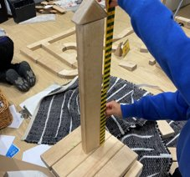
Through our play-based pedagogy, we ensure children have daily opportunities for uninterrupted play to allow depth in their learning. Our Continuous Provision allows for self-challenge, breadth and progression through a child-initiated approach. Through responsive planning and adult-directed planning, our learners can develop their skills, knowledge and understanding throughout the curriculum.
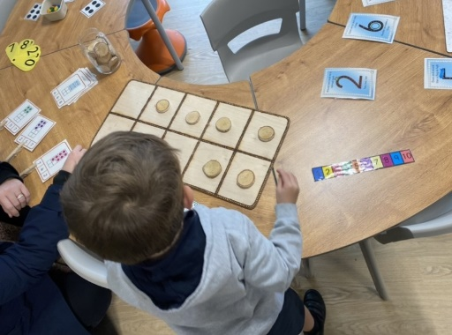
Children will participate in small, focussed group teaching in Literacy and Numeracy every day as well as having play opportunities across the provision. Children in P2 are expected to achieve targets/consolidation tasks throughout the week which are adult initiated experiences based on consolidation of prior learning or from our First level skills progression e.g., Art or Science. These targets could also be based on the needs and interests of the children.

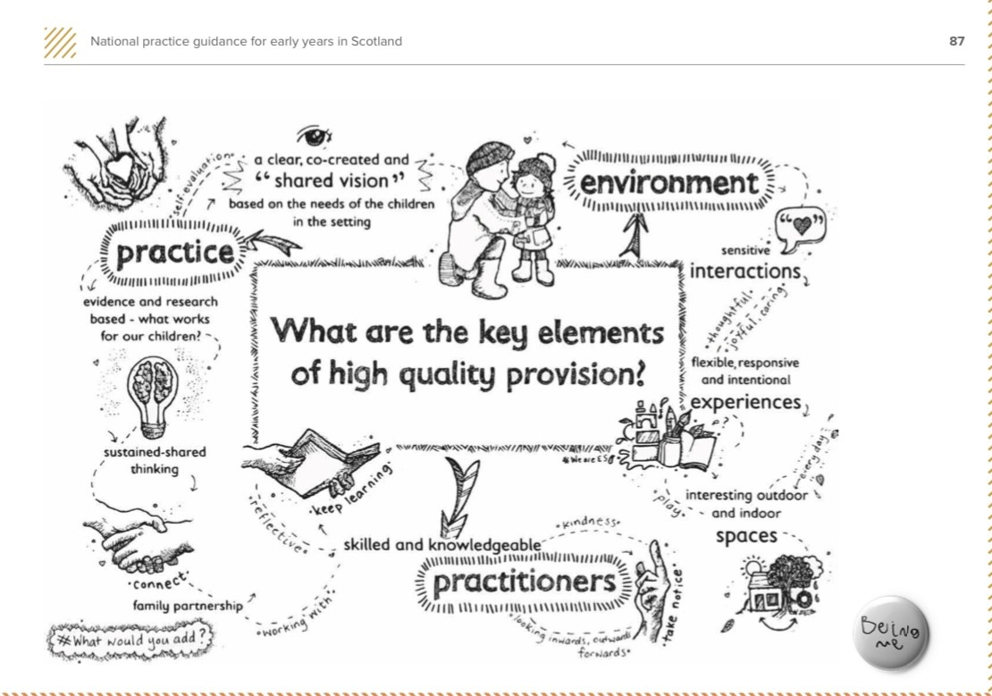

(Illustration from Realising the ambition: Being me 2020)
Play pedagogy progression
At South Morningside, our Play pedagogy progresses from Early Level in P1 through to First Level in P2 and P3. Our values and principles are the same, however we ensure that the play pedagogy is progressive to allow Early Level and First Level benchmarks to be achieved through a child centred approach. In P1 learners have free flow access across learning spaces and in P2 and P3 children have continuous provision set up in their individual classrooms.
P1-2 also have an outdoor classroom for play based learning.
Primary 1 | Primary 2 | Primary 3
Daily opportunities for free flow and structured play throughout the curriculum. | Daily opportunities for free flow and structured play throughout the curriculum. | Regular opportunities for open ended and structured play throughout the curriculum
Daily small group teaching for Literacy AND Numeracy | Daily small group teaching for Literacy AND Numeracy | Daily group or whole class teaching for Literacy AND Numeracy
Consolidation tasks to ensure challenge across the provision. | Regular follow up activity or consolidation tasks for Literacy and Numeracy | Daily follow up activity or consolidation tasks for Literacy and Numeracy
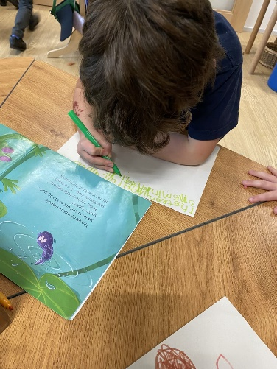
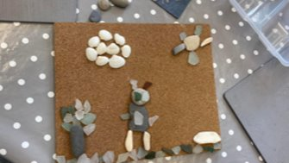

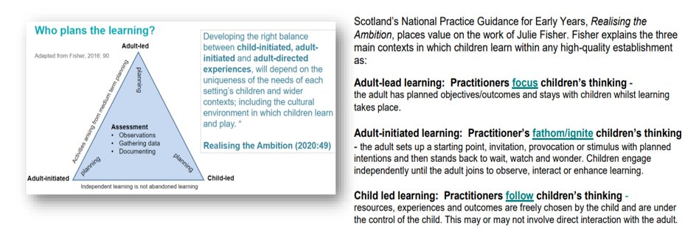
Throughout our play progression, we ensure a balance between adult- initiated learning and open ended, child-initiated opportunities based on the work of Julie Fisher (2016) as outlined below (Play for learning framework, Glow Scotland).

Observations
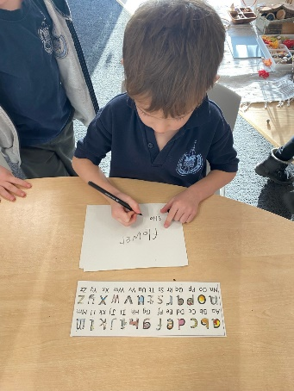
Observations are a key component of our learning, teaching and planning cycle. Practitioners are skilled in observing, recording assessments to show what and how children are learning and the progress being made. These observations are used to inform and are factored into our continuous provision plan, allowing experiences to meet the needs and interests of the children. P1 observations or ‘magic moments’ are also gathered and recorded in our floorbook which are shared with the class and reflected on regularly. P1 children’s progress across the curriculum is shared through our Online Learning Journals and parents have the opportunity to add achievements from home, building on that school- home link.

Appendix 1
Tina Bruce- The 12 Features of Play

1. Children use first hand experiences from life.
2. Children make up rules as they play in order to keep control.
3. Children symbolically represent as they play, making and adapting play props.
4. Children choose to play - they cannot be made to play.
5. Children rehearse their future in their role play.
6. Children sometimes play alone.
7. Children pretend when they play.
8. Children play with adults and other children cooperatively in pairs or groups.
9. Children have a personal play agenda, which may or may not be shared.
10. Children are deeply involved and difficult to distract from their deep learning as they wallow in their play and learning.
11. Children try out their most recently acquired skills and competences, as if celebrating what they know.
12. Children coordinate ideas and feelings and make sense of relationships with their families, friends and cultures.
